Week 2 Homework — Green Group
Palm Oil and the Rainforest
Palm oil is a very common oil. It is in many foods like biscuits and chocolate. It also helps make soap. This oil comes from palm trees that grow in warm places.
In Indonesia, people cut down wild rainforests to plant palm trees. This is a big problem for ecologists. Ecologists want to protect nature. When forests are cut down, wild animals lose their homes. In the book Berani, Malia wants to help the orangutans. She tells her school about the lost trees. Wild orangutans like Ginger Juice lose their forest homes. Ecologists say we must save the trees.
But local farmers need palm oil too. Farming palm trees helps them earn money. This money pays for food, houses, and school. Many families would be very poor without palm oil. Farmers want to help their children. Banning palm oil is not easy because other oil crops need even more land to grow. Today, people are trying to grow palm oil safely. They want to protect the forests and help the farmers at the same time.

Part A: Reading Comprehension
1. Where does palm oil come from?
A. Palm trees in warm places B. Cocoa beans in the forest
C. Soap factories in Malang D. Orange trees in cold places
2. Which of these foods contains palm oil, according to the text?
A. Oxtail soup B. Bananas and papayas
C. Fresh apples D. Biscuits and chocolate
3. What do people in Indonesia do to plant palm trees?
A. They cut down wild rainforests. B. They build new restaurants.
C. They grow them inside cages. D. They plant them in school gardens.
4. Who wants to protect nature, according to the text?
A. Shop owners B. Palm oil farmers
C. Ecologists D. Mynah birds
5. What happens to wild animals when forests are cut down?
A. They go to the city. B. They lose their homes.
C. They find more food. D. They learn to fly.
6. Who wants to help the orangutans in the book Berani?
A. A local farmer B. Malia
C. Ari's uncle D. Elvis Presley
7. What does Malia tell her school about?
A. The lost trees in the forest B. How to cook oxtail soup
C. The city of Surabaya D. Her favorite books
8. Who is Ginger Juice in the text?
A. A wild orangutan who lost her forest home B. A local farmer's child
C. A drink made with green oranges D. Malia's favorite teacher
9. Why do local farmers need to grow palm trees?
A. To clear the roads for trucks B. To make the forest look pretty
C. To earn money for their families D. To feed the wild birds
10. What does the money from palm farming pay for?
A. Trips to other countries B. Food, houses, and school
C. Supermarket toys D. Cage cleaning supplies
11. What would happen to many farming families without palm oil?
A. They would be very rich. B. They would be very poor.
C. They would move to Malang. D. They would become ecologists.
12. Why is banning palm oil not easy?
A. No one knows how to make soap. B. Other oil crops need even more land to grow.
C. Farmers do not like other plants. D. The trees are too hard to cut down.
13. What are people trying to do today with palm oil?
A. Grow it safely to protect forests and help farmers. B. Stop using it in all foods.
C. Make it only in factories. D. Move all palm trees to Canada.
14. Ecologists say we must save the:
A. Supermarkets B. Trees
C. Fences D. Roads
15. Farmers grow palm trees because they want to help their:
A. Friends B. Pets
C. Teachers D. Children

Part B: Mathematics Word Problems
16. A rectangular garden has a length of 6 metres and a width of 4 metres. What is its perimeter?
A. 12 metres B. 20 metres
C. 10 metres D. 24 metres
17. A rectangular desk is 5 metres long and 3 metres wide. What is its area?
A. 15 square metres B. 16 square metres
C. 30 square metres D. 8 square metres
18. A square sandpit has an area of 25 square metres. How long is one of its sides?
A. 5 metres B. 10 metres
C. 20 metres D. 4 metres
19. A rectangular playground has an area of 24 square metres. If the length is 6 metres, what is the width?
A. 18 metres B. 8 metres
C. 4 metres D. 12 metres
20. A rectangular rug has a perimeter of 18 metres. If its length is 5 metres, what is its width?
A. 13 metres B. 4 metres
C. 9 metres D. 8 metres
21. What is the total area of the L-shaped garden shown in the diagram?
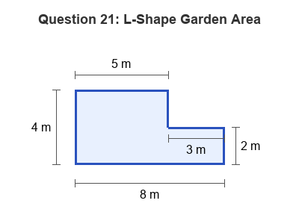
A. 14 square metres B. 30 square metres
C. 20 square metres D. 26 square metres
22. A square field has side lengths of 7 metres. What is the perimeter of the field?
A. 28 metres B. 14 metres
C. 49 metres D. 21 metres
23. A rectangular box lid has a perimeter of 30 centimetres. If the width is 5 centimetres, what is the length?
A. 10 centimetres B. 20 centimetres
C. 15 centimetres D. 25 centimetres
24. What is the total perimeter around the outside of this combined shape?
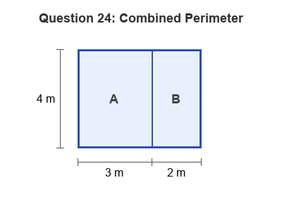
A. 24 metres B. 14 metres
C. 18 metres D. 20 metres
25. A farmer has a rectangular chicken coop that is 8 metres long and 5 metres wide. How many metres of fencing does the farmer need to go all the way around it?
A. 26 metres B. 13 metres
C. 16 metres D. 40 metres
26. A rectangular paddock has an area of 36 square metres. If the width is 4 metres, what is the length?
A. 32 metres B. 9 metres
C. 8 metres D. 6 metres
27. What is the perimeter of this L-shaped block?
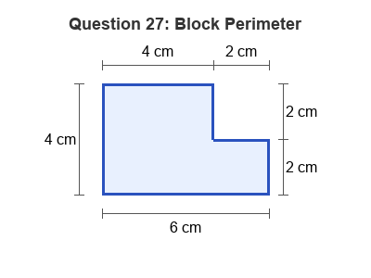
A. 20 centimetres B. 24 centimetres
C. 16 centimetres D. 18 centimetres
28. A square towel has an area of 81 square centimetres. What is the length of one side of the towel?
A. 18 centimetres B. 9 centimetres
C. 27 centimetres D. 36 centimetres
29. A rectangular poster is 10 decimetres long and 8 decimetres wide. What is the area of the poster?
A. 36 square decimetres B. 40 square decimetres
C. 18 square decimetres D. 80 square decimetres
30. A rectangular vegetable garden is 7 metres long and 3 metres wide. What is the area of the garden?
A. 14 square metres B. 10 square metres
C. 20 square metres D. 21 square metres

